**SMART HOME AUTOMATION**

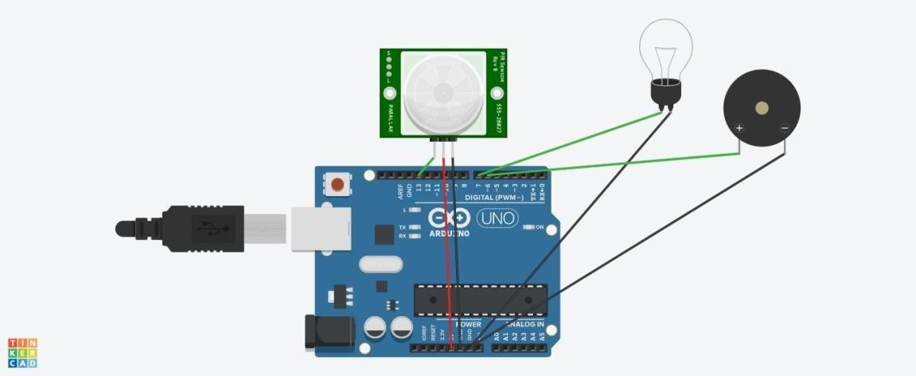

Void setup() { pinMode(13, INPUT); pinMode(7, OUTPUT); pinMode(6, OUTPUT);

} void loop() { digitalWrite(7,digitalRead(13)); digitalWrite(6,digitalRead(13));

}